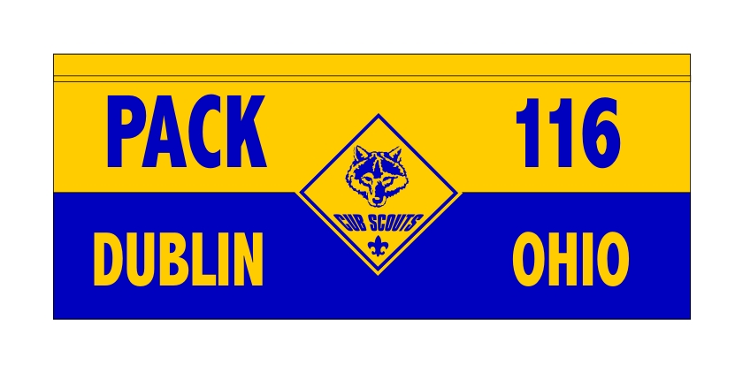
JOIN BAILEY PACK 116 FOR OUR
ANNUAL ST. PATRICK’S DAY PARADE MARCH!

When:
-Saturday, March 16th, 2013
Where:
-Lineup begins at 10 a.m.?
(Street assignment & Time for lineup to be announced.)
Attire:
-Scouts are asked to wear their Class A uniforms.
Notes:
-For those wanting to ride bikes, we will have a “Decorate Your Bike Night!” Friday, March 15th. Location TBD

-We will need some Scouts to walk to help carry flags and banner. Please contact Rion Myers (info below).

-Scouts will be provided with Irish flags to carry or place on bike.

-We ask anyone with Irish/Dublin "house" flags to bring them and carry as we march.

-We will need some Akela’s to help with bike decorations and events on day of parade. Rion will not be able to attend.

-Contact Rion Myers if you would like to help in ANY way:
Cell: 614-570-0071
Rion.Myers@KingThompson.com

